**Seek God for the City 2022 helps you pray with clarity**

**and biblical hope for others.**

* **Unites faith as many churches pray together with biblical substance.**
* **Fresh, vivid prayers that spring directly from scripture.**
* **Grows hope for God to bring forth transforming blessing in our cities.**
* **An app is available for your smartphone and tablet.**

PRAYING FORTY DAYS TO PALM SUNDAY

March 2 to April 10, 2022

Our church will be joining thousands of churches during the 40 days leading up to Palm Sunday.

*(Insert Your Information Here.)*

­

­­

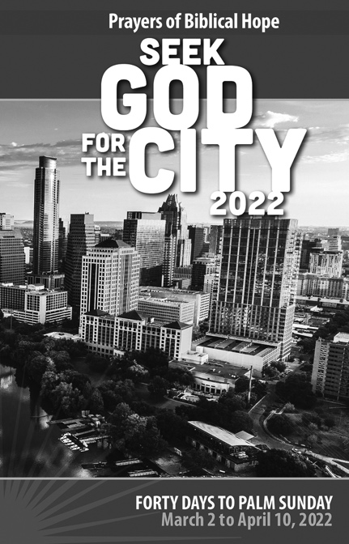­

*(Insert Your Information Here.)*

**Seek God for the City 2022 helps you pray with clarity**

**and biblical hope for others.**

* **Unites faith as many churches pray together with biblical substance.**
* **Fresh, vivid prayers that spring directly from scripture.**
* **Grows hope for God to bring forth transforming blessing in our cities.**
* **An app is available for your smartphone and tablet.**

Our church will be joining thousands of churches during the 40 days leading up to Palm Sunday.

PRAYING FORTY DAYS TO PALM SUNDAY

March 2 to April 10, 2022