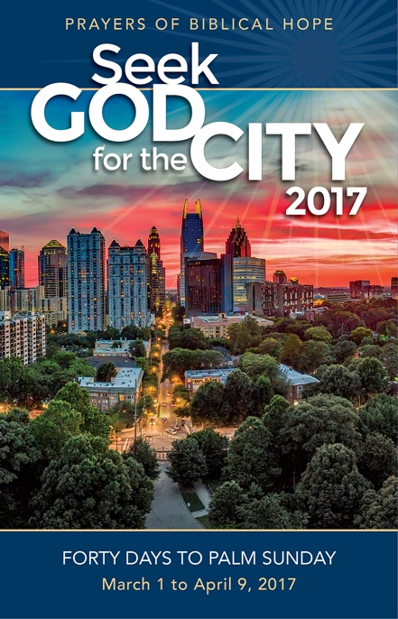

***Seek God for the City 2017* helps you pray with clarity**

**and biblical hope for others.**

* **Fresh, vivid prayers that spring directly from scripture.**
* **An app is available for your smartphone and tablet.**
* **Booklet format makes it possible to use on your own at any time and place, linking your prayer with many others.**
* **Sets a tone of hope and anticipation as we seek God’s face and Seek His kingdom.**

PRAYING FORTY DAYS TO PALM SUNDAY

March 1 to April 9, 2017

Our church will be joining thousands of churches during the 40 days leading up to Palm Sunday.

*(Insert Your Information Here.)*

***Seek God for the City 2017* helps you pray with clarity**

**and biblical hope for others.**

* **Fresh, vivid prayers that spring directly from scripture.**
* **An app is available for your smartphone and tablet.**
* **Booklet format makes it possible to use on your own at any time and place, linking your prayer with many others.**
* **Sets a tone of hope and anticipation as we seek God’s face and Seek His kingdom.**

PRAYING FORTY DAYS TO PALM SUNDAY

March 1 to April 9, 2017

Our church will be joining thousands of churches during the 40 days leading up to Palm Sunday.

*(Insert Your Information Here.)*

PRAYING FORTY DAYS TO PALM SUNDAY

February 18 to March 29, 2015