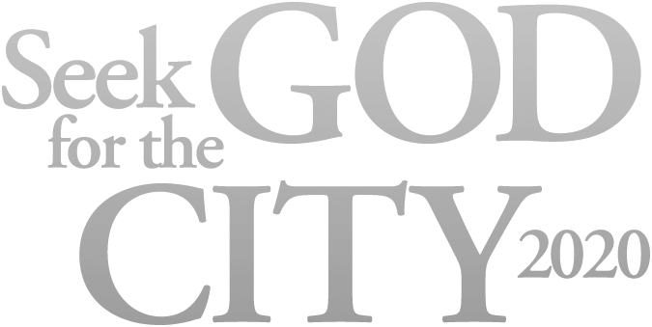­­

­

­­

­

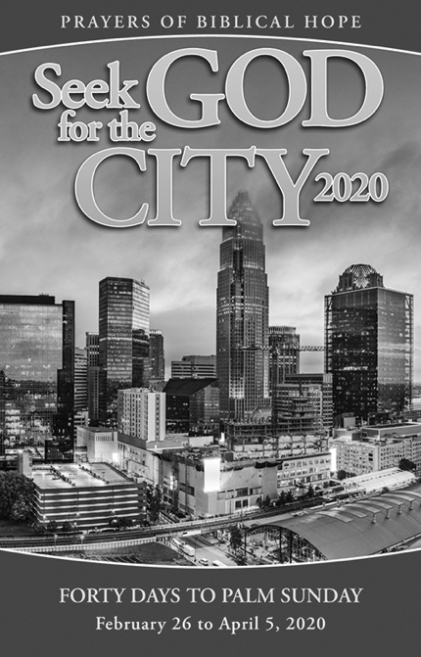

Our church will be joining thousands   
of churches in united prayer during   
the 40 days leading up to Palm Sunday.

Our church will be joining thousands   
of churches in united prayer during   
the 40 days leading up to Palm Sunday.

*(Insert Your Information Here.)*

***Seek God for the City 2020* helps you pray with clarity**

**and biblical hope for others.**

* Fresh, vivid prayers that spring directly from scripture.
* An app is available for your smartphone and tablet.
* Booklet format makes it possible to use on your own at   
  any time and place, linking your prayers with many others.
* Sets a tone of hope and anticipation as we seek God’s face   
  and Seek His kingdom.

PRAYING FORTY DAYS TO PALM SUNDAY

February 26 to April 5, 2020

*(Insert Your Information Here.)*

***Seek God for the City 2020* helps you pray with clarity**

**and biblical hope for others.**

* Fresh, vivid prayers that spring directly from scripture.
* An app is available for your smartphone and tablet.
* Booklet format makes it possible to use on your own at   
  any time and place, linking your prayers with many others.
* Sets a tone of hope and anticipation as we seek God’s face   
  and Seek His kingdom.

PRAYING FORTY DAYS TO PALM SUNDAY

February 26 to April 5, 2020